Insert photograph here
{Name}’s Switch Activity Book

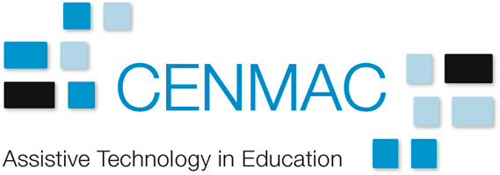

What’s in my Book

Morning Greetings 7
Hold to Play 8
Tickle Time 9
Tin Can Towers 1 10
Music Start & Stop 11
Five Red Planes 12
Pig Dog Derby 13
Dance Selector 14
Humans as Animals 15
Applause and Boo 16
Tin Can Towers 2 17
Nerf Gun 18
Go Baby, Go! 19
Book: Brown Bear 20
Book: The Train Ride 21
Book: Walking Through the Jungle 22
Book: We’re Going on a Bear Hunt 23
Book: The Animal Boogie 24
Book: Yuck! 25
Book: What do you like? 26
Book: The Very Hungry Caterpillar 27
Book: Hello, Goodbye 28
Matching Game 29
Cloze Procedures with Clicker 30
Catchy Orbit 31

My Access Methods
I use switches to participate in most of my activities. I also use a partner assisted scanning communication book on my iPad.

My Switches
I activate switches using different parts of my body. I try and rotate these around during the day. You may find some locations are better for some activities than others.

Head switch
Piko with Softy Top Candy Corn | I use a Piko Button with a Softy Top, or a Candy Corn Proximity Switch. I’m trying both while I figure out which I prefer.
Insert photograph of  access method here | Use my L3D mount to hold the switch in the right place by my right temple. Please make sure:  - It’s close enough that I don’t have to stretch  - It’s not so close that I can’t look around me  - It doesn’t interfere with my glasses

Hand switch
 | I use a buddy button with my right hand.
Insert photograph of  access method here | Please put this in a position where I can press it easily. I’m using my table suction mount to get this in the best place, which might vary a little from day to day.

About Switch Levels
Step 1 – Ascertain they understand cause-and-effect
Understanding that the switch does something is an incredibly important step in learning to use switches. Without this understanding, switch pressing becomes something that children might do every time without thinking when a switch is presented to them, sometimes known as “swatting.” Once the young person understands that the switch activates the lights, or vibrating cushion, or prompts mum to tickle them, etc., then we can happily move on to the next step.
At this point we’re not looking to teach the pupil a new movement for switch access as we want them to fully concentrate on learning cause-and-effect. Therefore at this stage simply use an existing movement, which may be temporary.
Step 2 – Find reliable switch sites with one switch that does many things
Once the person understands that the switch does a load of really cool stuff they are likely to put some effort into using movements which they might find difficult. Work around the person’s body to find at least two, if not more, movements that reliably activate a single switch. It doesn’t matter if these seem clumsy or take a while to initiate – we’ll improve through practice. Bring lots of activities and have lots of fun. Some people at this point seem to “lose” their understanding of cause and effect. It’s more likely that they’ve become bored of the activities…
Step 3 – Use two switches that do many things each
Having two switches in two different parts of the body is an exciting leap forward that requires improved coordination, problem solving, sequencing, making choices and a load of other skills. Fortunately, you can learn these skills through fun activities.
At this stage we want to give the young person an option of pressing one of two switches. Try not to encourage an answer to be ‘wrong’ – let them explore and react accordingly.
Step 4 – Use two switches that scan or build (errorless)
At this point the young person is motivated and coordinated to use two switches. It’s a good time to introduce the rather peculiar concept of scanning, which involves one switch interacting with the other. Scanning needs to be taught through error-less means, as even teachers can get confused as to how it works! Start with lots of games that involve the basics of scanning but where there is no right or wrong answer.
Step 5 – Use two switches to scan with more functionality
By providing scanning we are providing choice, and we’re able to interpret that choice as an intentional and meaningful way to communicate. Playing computer games that involve scanning to particular cells to ‘win’ is a good start, as is our role in interacting to utterances from a communication aid. At this point we assume that if someone scans on the communication aid and says something – they mean it and we act accordingly.
What if my student can’t use two switches?
Single switch scanning requires significantly more attention and cognitive resources than two-switch scanning. Additionally, relying on a single point of movement to control their world can cause complications in the future. So do try to find to as many switch sites as practical, and do involve an occupational therapist to help. You can ask the family and other people who know the person if they themselves can’t identify movements.
There are cases where you will need to use a single switch. In these circumstances consider practicing some games that involve timing before moving onto scanning. For information on timing activities see the Inclusive Technology / Ian Bean Switch Progression Roadmap.

Morning Greetings
Level
1&2
One switch does one thing (press and release)
I use a talking switch to say good morning to my friends, staff, and new people when I arrive to school in every morning.
What you’ll need
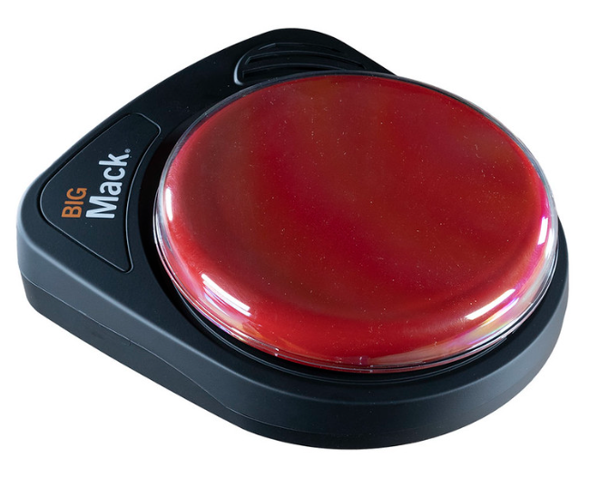 | You’ll need to record a “Good Morning” message onto a BIGMack talking switch.
 | Plug one of my switches into the BIGMack and position my switch so I can use it.

Hold to Play
Level
1&2
One switch does one thing when held
When I hold down my switch music is played. When I let go it stops playing straight away. By experimenting with the switch I can quickly learn the nature of cause and effect.
What you’ll need
 | An iPad with the RadSounds app.
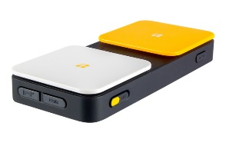 | A Blue2 Switch Interface
 | Plug one of my switches into the Blue2 and position my switch so I can use it.

Tickle Time
Level
1&2
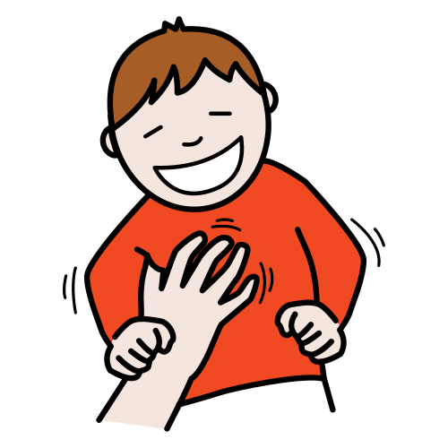
One switch does one thing (press and release)
I love being tickled! When I press my switch start tickling me straight away very lightly on my sides. Tickle me for four seconds and then stop! You can tickle me again if I ask for it
What you’ll need
You’ll need to record a “Tickle Me” message onto a BIGMack talking switch.

Plug one of my switches into the BIGMack and position my switch so I can use it.

Tin Can Towers 1
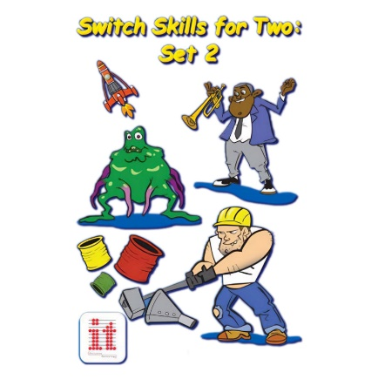
Level
1&2
One switch does one thing (press and release)
An adult or a classmate uses one switch to build up the tower and I use my switch to smash it down. This really helps me build my turn-taking and joint attention skills and it’s fun to play a game with someone.
What you’ll need
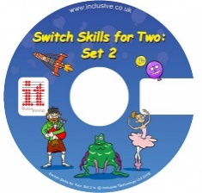 | Switch Skills for 2 set 2 app on the PC
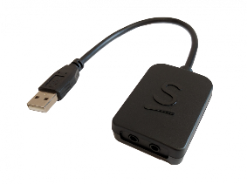 | A JoyCable Switch Interface
 | Plug one of my switches into the JoyCable and position my switch so I can use it.

Music Start & Stop
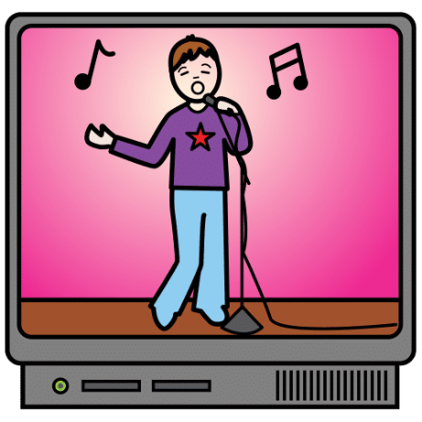
Level
1&2
One switch does one thing (press and release)
Use a talking switch to say “more” so that I need to press my switch to keep the music going. Try stopping every four seconds and then give me a whole song at the end as a reward.
YouTube is useful here but you can also use iTunes, Spotify or any other music player.
What you’ll need
You’ll need to record a “More” message onto a BIGMack talking switch.

Plug one of my switches into the BIGMack and position my switch so I can use it.

Five Red Planes
Level
1&2
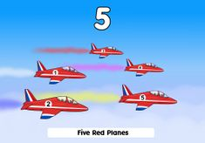
One switch does one thing (press and release)
This is my favourite game on HelpKidzLearn although I might get bored if I play it too much! When I press my switch a new plane is added and a song is played. I need to watch out for the cues so I know when to press my switch.
What you’ll need
HelpKidzLearn website (you might need the username and password) on a PC.

A JoyCable Switch Interface
Plug one of my switches into the JoyCable and position my switch so I can use it.

Pig Dog Derby
Level
3
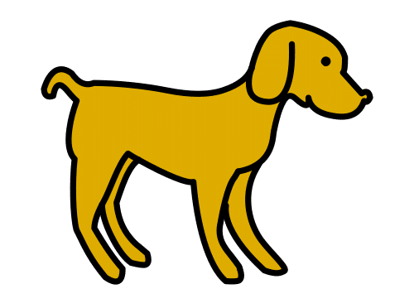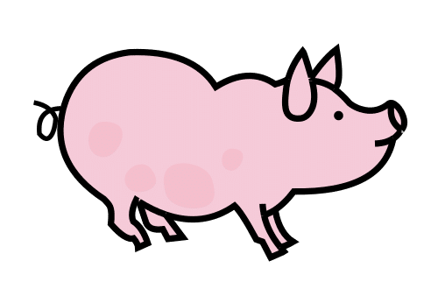
Two switches do two different things
I use both my switches to race Mr Piggy and Mr Doggy. Don’t forget to sabotage the race with puddles, potholes and other surprises!
What you’ll need
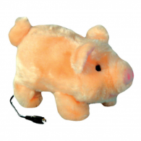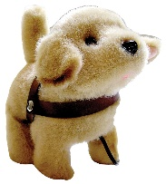 |  | A switch accessible walking pig & dog
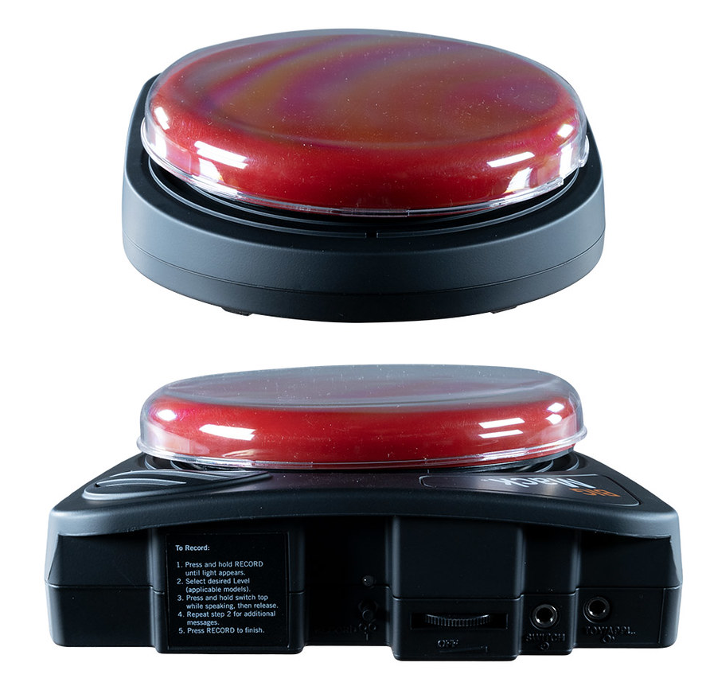 | Two talking switches. Record “Boo!!” message onto one BIGMack talking switch. Record “Bravo!” and clapping sounds onto the second BIGMack.
 | I’ll need both my hand switch and my head switch set up at the same time for this to work.

Dance Selector
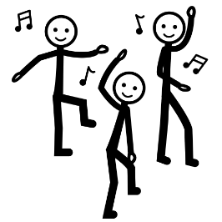
Level
4
Easy, errorless scanning with two switches
I use two talking switches to choose people to dance. The first switch scans through a group of willing people and the second switch tells that person to dance.
When you hear me say “next” someone should stand or raise their hand so I know you’ve heard me. If I say “next” again you can sit down and then next person should raise their hand or stand up. If I ask you to “dance” then please strut your stuff!
What you’ll need
You’ll need two talking switches for this to work. Record “Next” message onto one BIGMack talking switch. Record “Dance” message onto the second BIGMack.
I’ll need both my hand switch and my head switch set up at the same time for this to work.

Humans as Animals
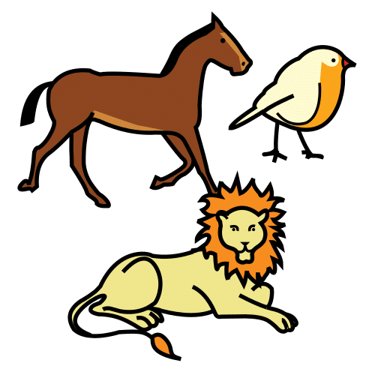
Level
3
Easy, errorless scanning with two switches
I use two talking switches to choose people to take turns making animal noises. The first switch scans through a group of people and the second switch tells that person to make an animal sound (of their choosing).
When you hear me say “next” someone should stand or raise their hand so I know you’ve heard me. If I say “next” again you can sit down and then next person should raise their hand or stand up. If I ask you to “make an animal sound” then please do your best!
What you’ll need
You’ll need two talking switches for this to work. Record “Next” message onto one BIGMack talking switch. Record “Make an animal sound” message onto the second BIGMack.
I’ll need both my hand switch and my head switch set up at the same time for this to work.

Applause and Boo
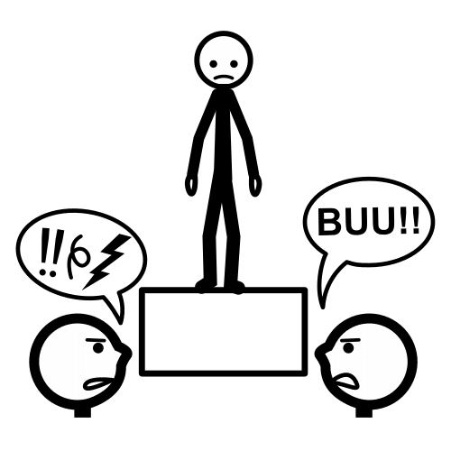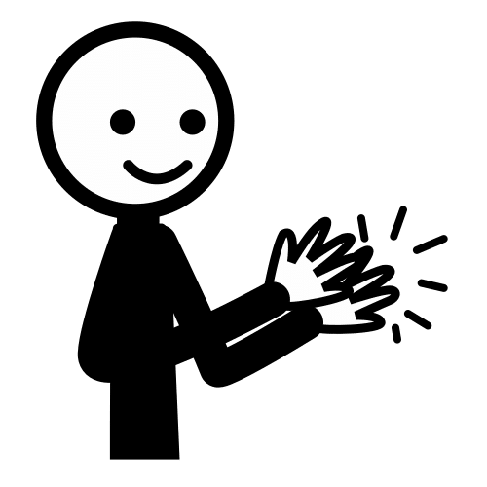
Level
3
Two switches do two different things.
Deliver a little talent show or ask people to tell jokes. I can then choose to applaud or to shout booooo!!!
What you’ll need
You’ll need two talking switches for this to work. Record “Boo!!” message onto one BIGMack talking switch. Record “Bravo!” and clapping sounds onto the second BIGMack.
I’ll need both my hand switch and my head switch set up at the same time for this to work.

Tin Can Towers 2
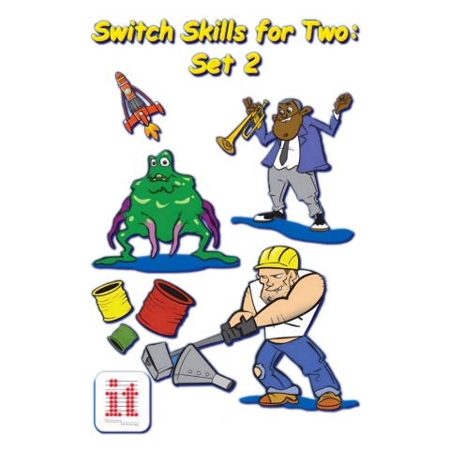
Level
4
Two switches do two different things
I’m using one switch to build the tower and the other switch to smash it down!
What you’ll need
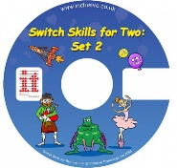 | Switch Skills for 2 set 2 app on the PC
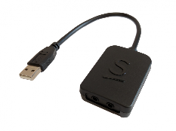 | A JoyCable Switch Interface
 | I’ll need both my hand switch and my head switch set up at the same time for this to work. Plug them into the JoyCable!

Nerf Gun
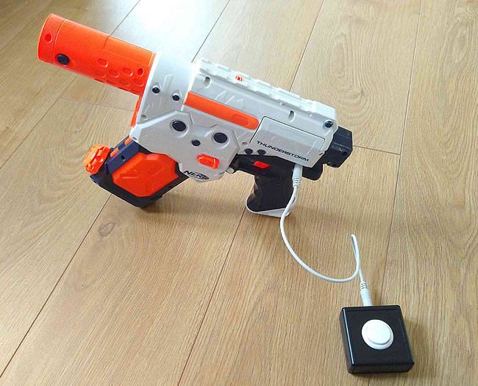
Level
1&2

One switch does one thing (press and release)
I love shooting at my classmates and teachers using my nerf gun.
What you’ll need
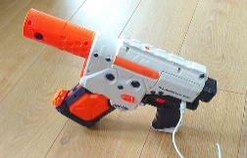 | My super cool nerf gun
 | Plug one of my switches into the NerfGun and position my switch so I can use it.

Go Baby, Go!
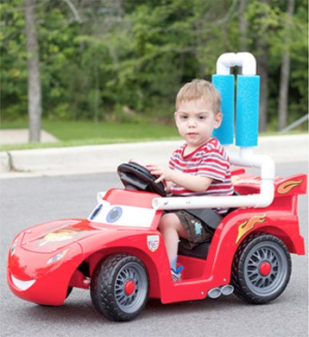
Level
1&2

One switch does one thing when held
I love to drive my car! I do this outside so just make sure I’m comfy and safe in the seat and that I can reach my hand switch. Off I go!
What you’ll need
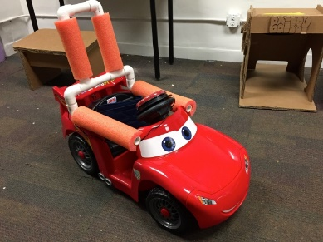 | My adapted car! There’s already a big switch mounted to the steering wheel.

Book: Brown Bear
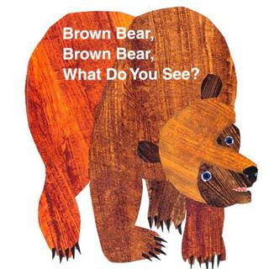
Level
3
Two switches do two different things.
This is one of my favourite books and I can join in by saying “What” and “See.” You can make this more interesting by nominating a class friend to pull items out of a box.
What you’ll need
You’ll need the book “Brown Bear Brown bear what do you see?” by Bill Martin Jr

You’ll also need two talking switches for this activity to work.

Record “What” message onto one BIGMack talking switch. Record “See” onto the second BIGMack.
I’ll need both my hand switch and my head switch set up at the same time for this to work.

Book: The Train Ride
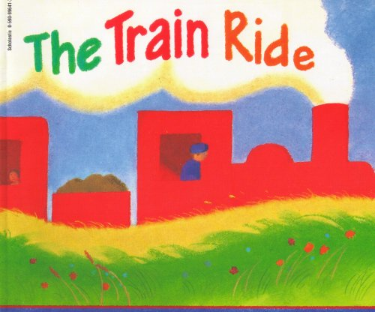
Level
3
Two switches do two different things.
You can get the whole class involved by creating a train with chairs placed one in front of another. You could also bring up train destinations on the whiteboard.
What you’ll need
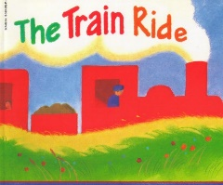 | You’ll need the Book “The train Ride” by June Crebbin.
You’ll also need two talking switches for this to work.

Record “What” message onto one BIGMack talking switch. Record “See” onto the second BIGMack. You could also choose to use “Go” and “Stop.”
 | I’ll need both my hand switch and my head switch set up at the same time for this to work.

Book: Walking Through the Jungle
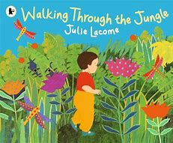
Level
3
Two switches do two different things.
You can get the whole class involved by moving around the classroom, using the whiteboard to bring up scenes.
What you’ll need
You’ll need the book “Walking through the Jungle” by Julie Lacome
You’ll also need two talking switches for this activity to work.

Record “What” message onto one BIGMack talking switch. Record “See” onto the second BIGMack. You could also choose to use “Go” and “Stop.”
I’ll need both my hand switch and my head switch set up at the same time for this to work.

Book: We’re Going on a Bear Hunt
Level
3
Two switches do two different things.
You can get the whole class involved by filling the class with obstacles and moving around the classroom, bring up scenes on the whiteboard.
What you’ll need
You’ll need the book “We’re going on a bear hunt” by Michael Rosen
You’ll also need two talking switches for this to work.

Record “Over” message onto one BIGMack talking switch. Record “Under” onto the second BIGMack. Can be used to instruct the class to go over and under obstacles.
I’ll need both my hand switch and my head switch set up at the same time for this to work.

Book: The Animal Boogie
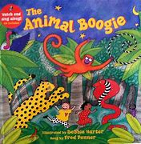
Level
3
Two switches do two different things.
What you’ll need
You’ll need the book “The Animal boogie” by Debbie Harter.
You’ll also need two talking switches for this to work.

Record “Here” message onto one BIGMack talking switch. Record “There” onto the second BIGMack.
I’ll need both my hand switch and my head switch set up at the same time for this to work.

Book: Yuck!
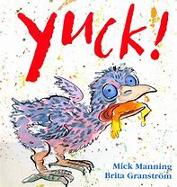
Level
3
Two switches do two different things.
What you’ll need
You’ll need the book “Yuck!” by Mick Manning & Brita Granstrom.
You’ll also need two talking switches for this activity to work.

Record “Yum!” message onto one BIGMack talking switch. Record “Yuck!” onto the second BIGMack.

You can also play a game with a range of food and other items you may or may not like to eat – yum and yuck.
I’ll need both my hand switch and my head switch set up at the same time for this to work.

Book: What do you like?
Level
3
Two switches do two different things.
You can read this book together or involve the class by doing a survey asking what they like and don’t like.
What you’ll need
You’ll need the book “What do you like?” by Michael Grejniee.
You’ll also need two talking switches for this activity to work.

Record “I like!” message onto one BIGMack talking switch. Record “Not!” onto the second BIGMack.
I’ll need both my hand switch and my head switch set up at the same time for this to work.

Book: The Very Hungry Caterpillar
Level
3
Two switches do two different things.
What you’ll need
You’ll need the book “The very hungry caterpillar” by Eric Carle
You’ll also need two talking switches for this activity to work.

Record “More” message onto one BIGMack talking switch. Record “Finished” onto the second BIGMack.
I’ll need both my hand switch and my head switch set up at the same time for this to work.

Book: Hello, Goodbye
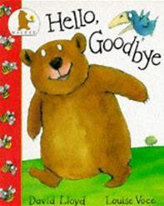
Level
3
Two switches do two different things.
We can read this book together or involve everyone by saying hello and goodbye to people as I travel around the school.
What you’ll need
You’ll need the book “Hello, Goodbye” by David Lloyd
You’ll also need two talking switches for this activity to work.

Record “Hello” message onto one BIGMack talking switch. Record “Goodbye” onto the second BIGMack.
I’ll need both my hand switch and my head switch set up at the same time for this to work.

Matching Game
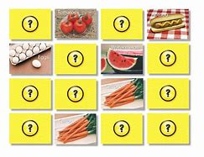
Level
3
Two switches do two different things.
This is the classic memory matching game, play with other students who can choose cards.
What you’ll need
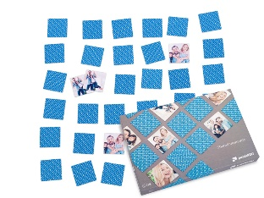 | Picture cards or photo pairs (e.g. from Puzzle You)
You’ll also need two talking switches for this activity to work.

Record “Same” message onto one BIGMack talking switch. Record “Different” onto the second BIGMack.
 | I’ll need both my hand switch and my head switch set up at the same time for this to work.

Cloze Procedures with Clicker
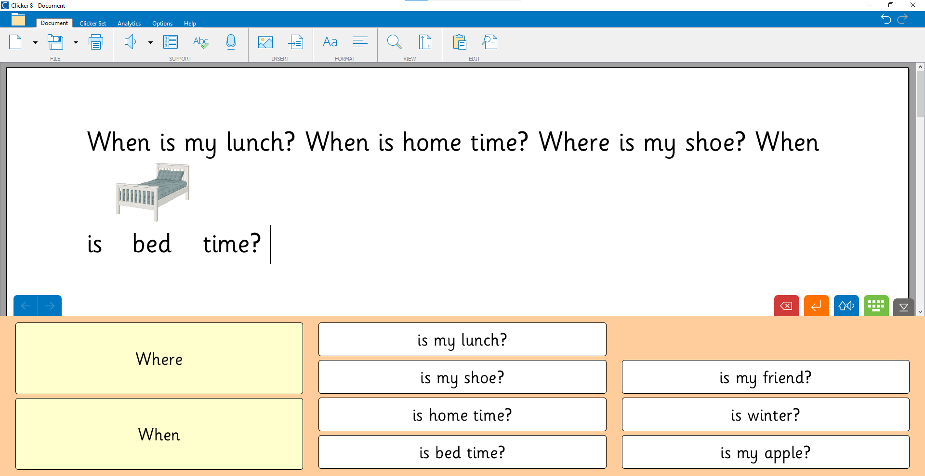
Level
3
Two switches do two different things.
Clicker is usually accessed via scanning, which is a skill learnt after Level 2. Here we’re building sentences with two buttons, choosing from two words.
What you’ll need
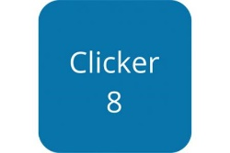 | You’ll need Clicker 8 app on a Windows computer or the Clicker Writer app on an iPad. If you don’t have Clicker you can use paper
You’ll also need two talking switches for this activity to work.

Record “Where” message onto one BIGMack talking switch. Record “When” onto the second BIGMack.
 | I’ll need both my hand switch and my head switch set up at the same time for this to work.

Catchy Orbit
Level
1&2
One switch does one thing (press and release)
What you’ll need
Catchy Orbit (if not installed on the PC you can download from OneSwitch.org.uk)

A JoyCable Switch Interface
Plug one of my switches into the JoyCable and position my switch so I can use it.

Top Tips for {Name}

Remember if I’m not doing it it’s most likely because I’ve got bored or it’s too easy and it’s time to move on! I also get tired and so make sure I get a chance to rest, and sometimes think about moving my switch to an easier place to reach it.

Please come up with new activity ideas!
I enjoy any activity that involves people so feel free to try stuff out and if it works well then add it to this book
How to record messages on the BIGMack
- Press and hold RECORD until light appears
- Press and hold switch while speaking
- Press RECORD to finish
Prompting
I don’t need verbal or physical prompting to press my switch. I just need you to wait. If you prompt me I may get distracted and forget about the switch.
If I don’t do anything then please show me how to use the switch yourself – and consider changing the activity for something more exciting!
Activities marked as Level 3 can be adapted as Level 1 and 2 with one switch
Make the most of two switches by having a class peer press the second switch. This is great for collaboration and turn taking.
Getting Help
Please contact CENMAC for any help.

